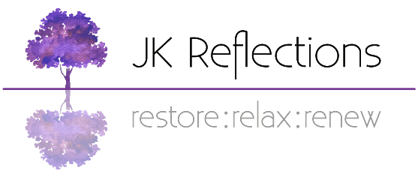

Salon Policy - JK Reflections

Logistics

Parking – please park on our drive, which is to the right of the house as you look at it. There will already be one or two cars parked there, which we will position as required to leave a space for you.

Appointment timing - To allow sufficient cleaning time, I ask that you attend your appointments as close to the appointment time as possible. Please do not turn up more than 5 minutes early for appointments, thank you.

Booking Appointments

New clients – you will be asked to complete a consultation form in advance, and to return it by email before your treatment session. Failing to return your consultation form in good time may mean that your appointment has to be moved to a later date.

Current clients – if there has been a gap of more than 6 months since your last treatment I will check with you for any changes to your medical status since you last attended. A gap of 12 months or more requires a new form to be completed.

Please note that I ask for your mobile phone number so that I can send you a reminder text message the day before your appointment.

Payment

Please pay for your treatment either by bank transfer or contactless card (I have a card machine). I also have the option of a QR code which can be scanned via your phone camera – this takes you to a secure SumUp page where you can enter your card details.

If paying by bank transfer please do so within the 12 hours following your treatment.

I do not accept cash.

Non-COVID cancellation policy

As I run a reserve list I request that all cancellations are made with as much notice as possible so that I can try to fill your empty appointment slot.

If you cancel your appointment with less than 24 hours notice I reserve the right to charge a cancellation fee.

If you cancel with less than 6 hours notice, and I am unable to fill the slot from my reserve list, or if you don’t attend for your appointment without cancelling first, the full amount will be due.

Each case will be assessed individually, and no fee will be charged if you test positive for, or are isolating because of, COVID or if you have cold/flu-like symptoms.

COVID SPECIFIC

Whilst COVID numbers have declined, COVID, flu and other viruses are still around in the community currently. Please therefore note the following:
- I will request that you postpone your appointment if you feel unwell, have a temperature or active cold symptoms as this increases the likelihood that you could pass on the virus you are suffering from - some of my clients are vulnerable and so I need to bear this in mind.
- I will ask you to sanitise your hands before entering the property and I will thoroughly ventilate the treatment room after each client.

If you or any of the people you live with display any cold or flu symptoms in the couple of days before your session please inform me asap. We will discuss the symptoms and whether we need to defer your appointment to a point when the symptoms have stopped. Please DO NOT attend if you have cold-like symptoms unless you have spoken to me first, as I may need to postpone your appointment.

NB You will not be charged for any appointments which you miss due to COVID symptoms or self-isolation.

Thank you for your understanding. Please contact me if you have any questions.

Jo Kerr

Owner - JK Reflections
74 Moat Way, Swavesey, CB24 4TR

